Motor learning and synaptic plasticity

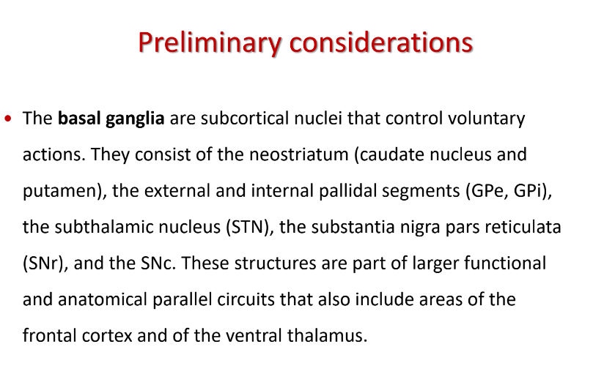
Pyramidal and extrapyramidal system

Number of nuclei subcortical involved in a complex process of information to filter motor signals. Involve in control of voluntary action

Neostriatum: made of caudate and putamen.
Two portions of globus pallidus (divided in external and internal)

These areas connect to the thalamus and back to the cortex

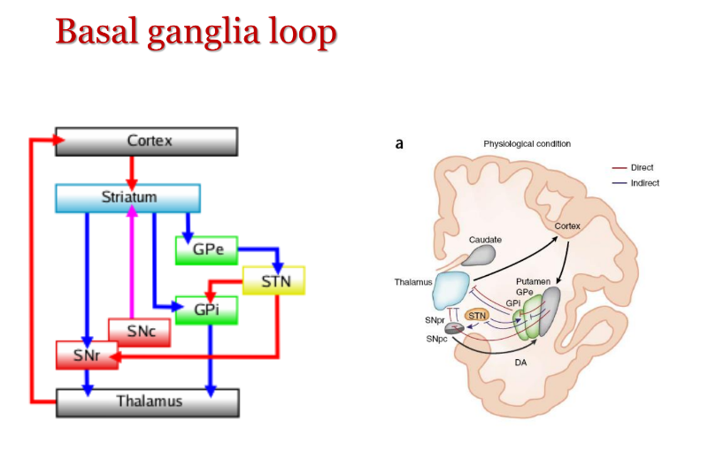
From the cortex down to the first area (striatum) and then globus pallidus and to the thalamus and back to the cortex

This is a loop that closes in the thalamus and back to the cortex

The scope is to filter the decision for a given movement and action. If I have to learn a new movement I need to be precise and to modulate correctly my action
If I learn a new sport my brain needs to learn a new action. We need a lot of precision in the movement

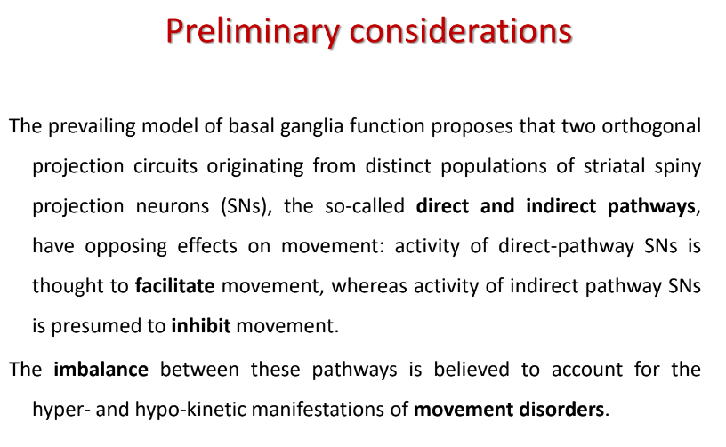
We have two systems working in opposite way
- Direct pathway: facilitate the movement
- Indirect pathway: inhibit the movement

We have a combination of stimuli that modulate the final action. The impairment of this balance will lead to motor disorder (movement disorder and parkinson and tics)

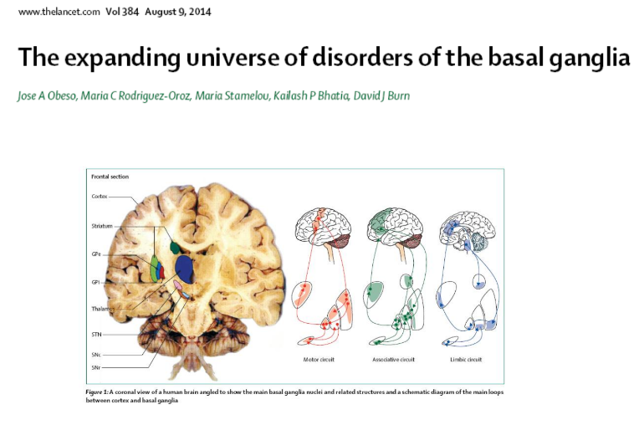
Leads to an increasing number of diseases from parkinson, tourette, …

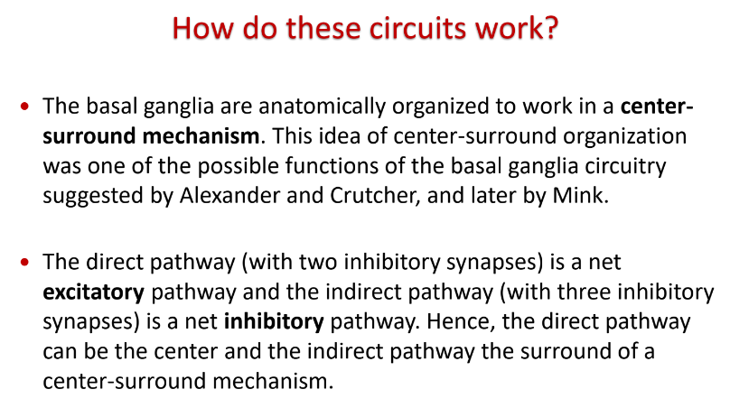
Basal ganglia organized in center-surrounding mechanisms. The message flowing in the center is promoted while what is in the surround is inhibited

The direct pathway is the center while the indirect pathway is the surround. It is a sort of signal to know-ratio. When we use the headphones are created to abolish some frequencies that might disturb some frequencies
the noise should be avoided

the noise should be initiated to allow the correct movement to be manifested.

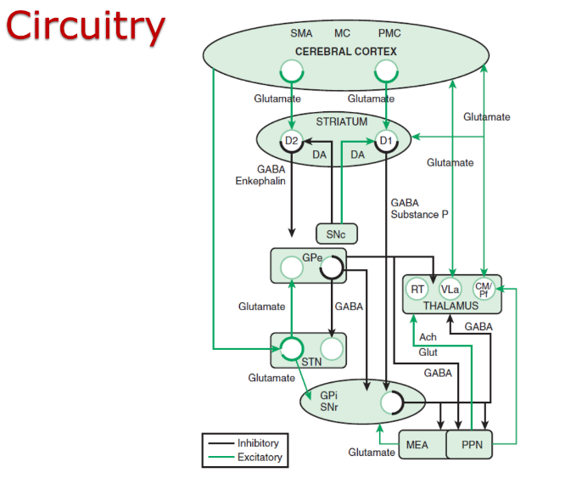
Actually is more complex, there are highways and parallel loops that work together with other streets.

Much more complex, we have an element of complexity that is chemistry and neurochemistry. A signal from cerebral cortex that goes in striatum will have glutamate (that excite the message)

In striatum we have the starting of the direct and indirect pathway.

We have a signal that generates a loop that goes down to basal ganglia and through the thalamus it goes back to the cortrex.

There are some additional complications.

REMEMBER: presence of loop that goes down to basal ganglia and filters messages and back to the cortex.

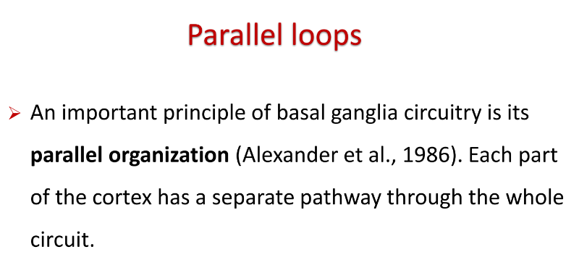
Many experimental findings were obtained from multiple experimental works on primates. Stimulating and area and inhibit an area.

One idea was that we have a parallel organization of the pathway

The cortical region is so large and with that it can generate tens of several parallel loops. When we do something we are not necessarily doing one thing
(Talking, moving, ...) parallel loops go always ahead (unless you have some problems)

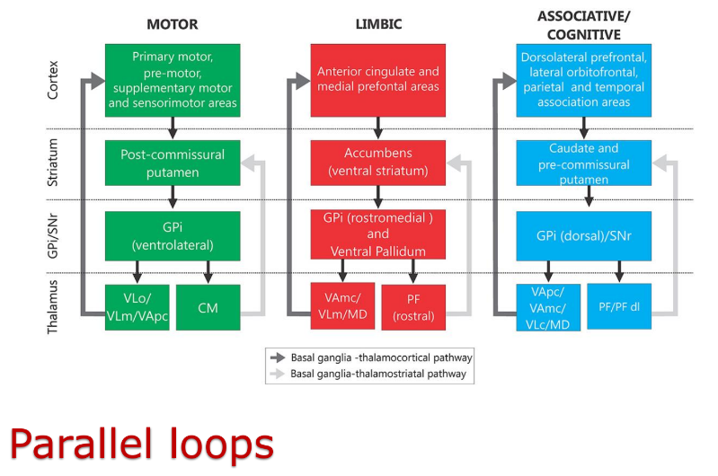
we have 3 parallel loops
- Motor payway:
- Limbic pathway: involved in emotion to some movements
- Associative/cognitive pathway: relevant to understand and retrieve what we know about an action. When I stop doing something for some years (like riding a bike) we need to retrieve the information just to do the action without learning it again

those areas can interact with each other but maintain separate loops

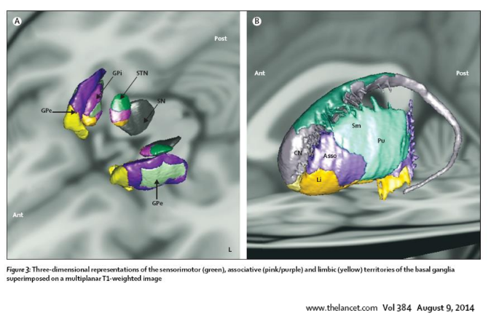
depending on the color there are regions more or less devoted to one of those loops.
⟹ this is a 3D reconstruction of human MRI.

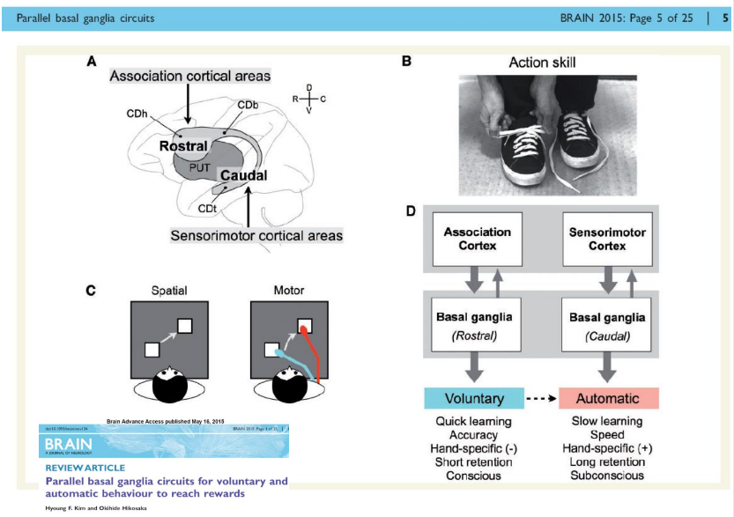
Combination of two tasks (like tie the shoes). One is voluntary and the other is automatic. Often the voluntary becomes automatic. After some practice it becomes an automatic movement
If we see a baby put the shoes on they are learning how to do it and they are practicing.

Parkinson slows down the movement but does not delete those files. Even with a stroke if the motor area is involved we can not be able to compensate.
Apraxia: inability to perform a movement because the cortical layers are gone. This happens with a number of people with dementia.
Same with language (bruce willis with fronto-terminal dementia) ⟹ inability to speak and produce sound with a sense. He lost the ability to put together words.



How do the basal ganglia contribute to movement?

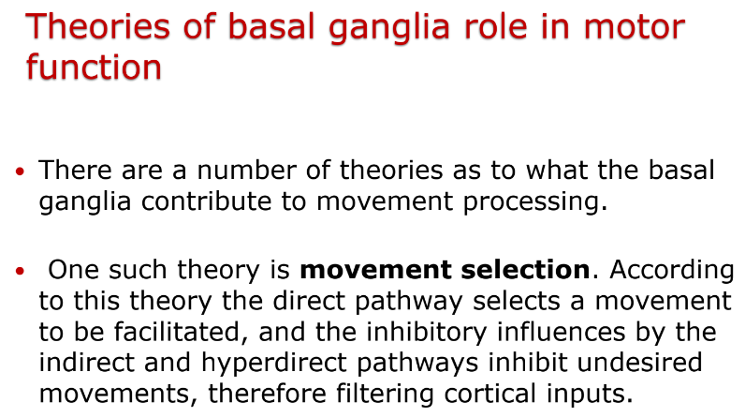
Different theories. We care about selection of movement. Excitatory pathway select a given movement. The indirect pathway inhibit other movement (like going in other directions).
Give precise sequences of movements to follow to reach the final goal.

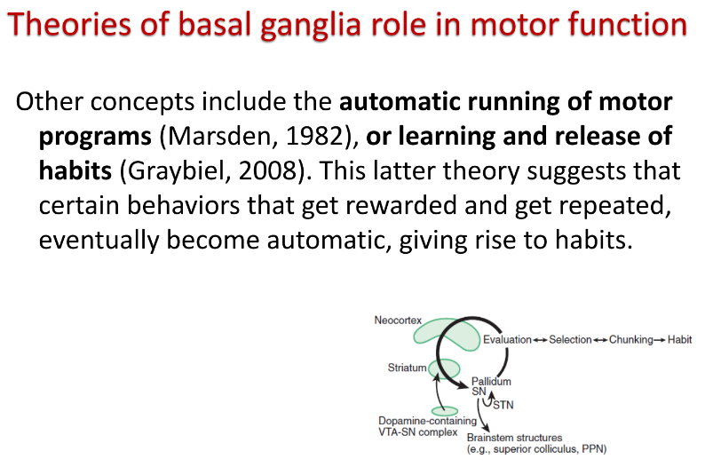
Automatic running of motor programs: like babies with mother breasts, even if nobody told them to do it.
All our actions (including the one well remembered) are intended as habits AKA repeated movements can be considered habits, we call habits and then we realize them.

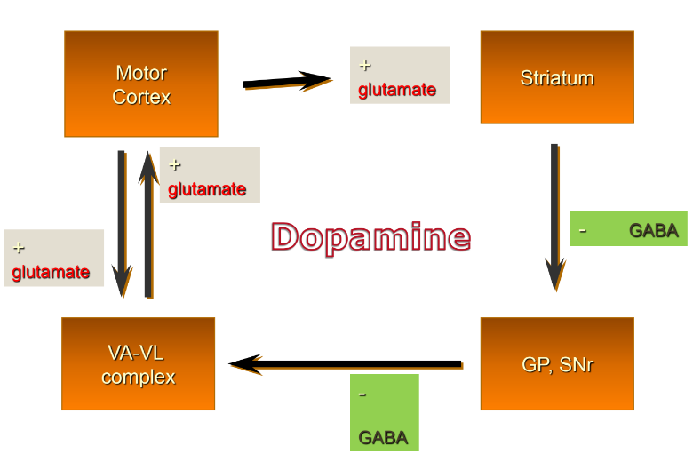
how dopamine is a key to understanding movement disorders.
If we take dopamine out of the system we have parkinson diseases

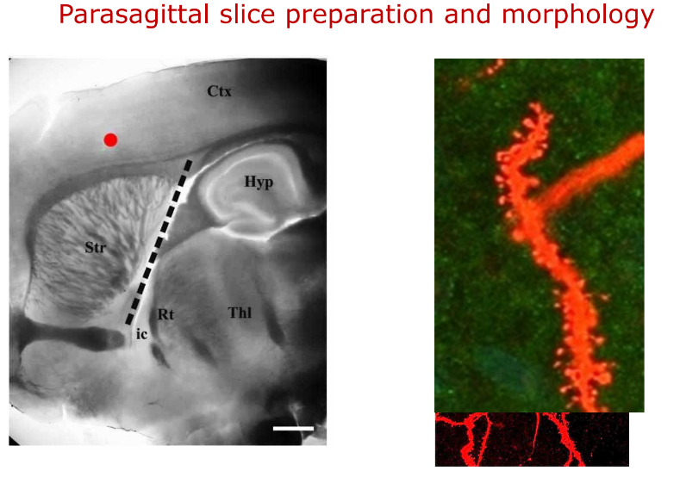
We can visualize cells and the cells have a prolongation (dendrites) that have buttons (called spines). The spine represent a new contact with a neuron in order to communicate

in cortical regions visual cortex in occipital area. If a kitten when is born is covered one of two eyes the occipital cortex will not develop, no growth in occipital connection and no spines

if you let the neurons expand they create a complicated connection between other neurons.

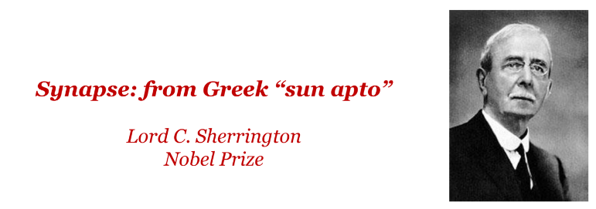
synapses

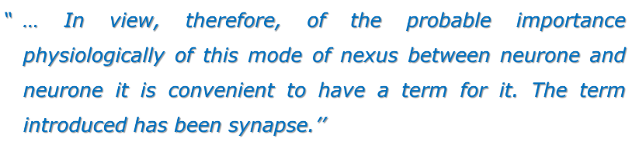

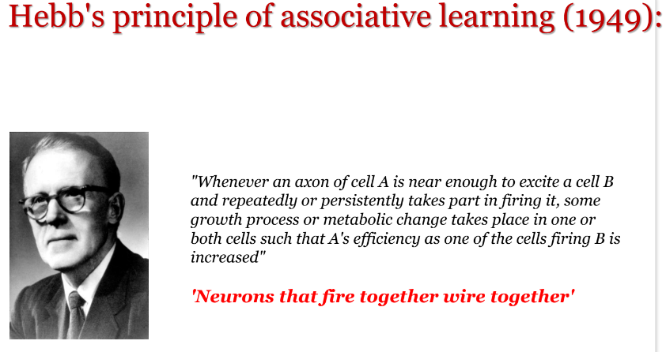
Hebb: Neurons that fire together wire together
Hebb introduced synapses plasticity. Plasticity is what was proposed in the 50s by Hebb

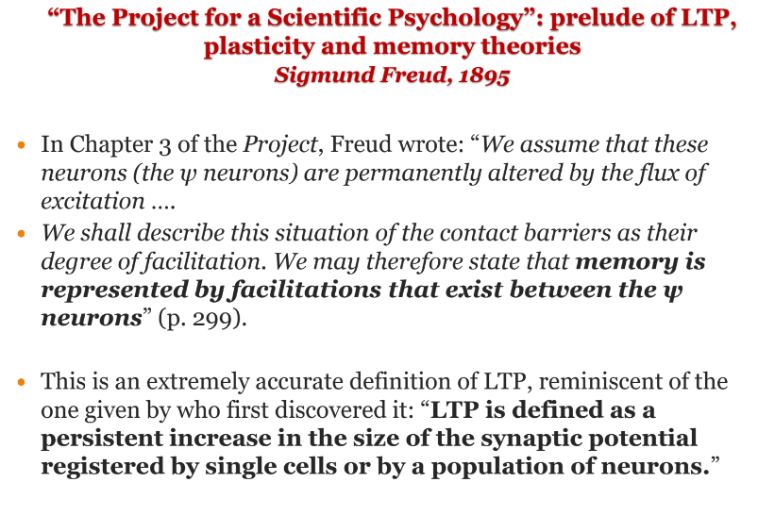
Even Freud had an intuition. Extremely accurate descriptions increase by Hebb about synaptic plasticity.

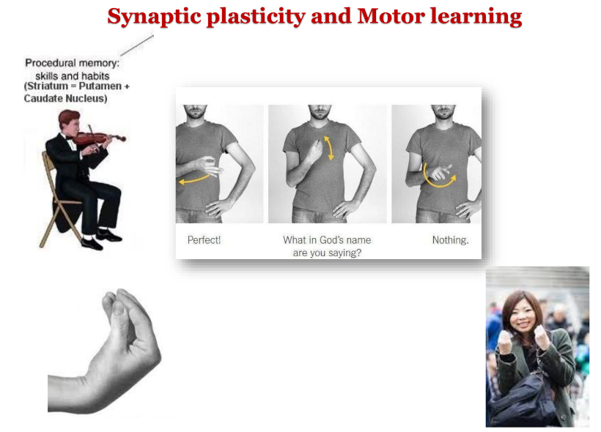
movement generated and learning as automatic.

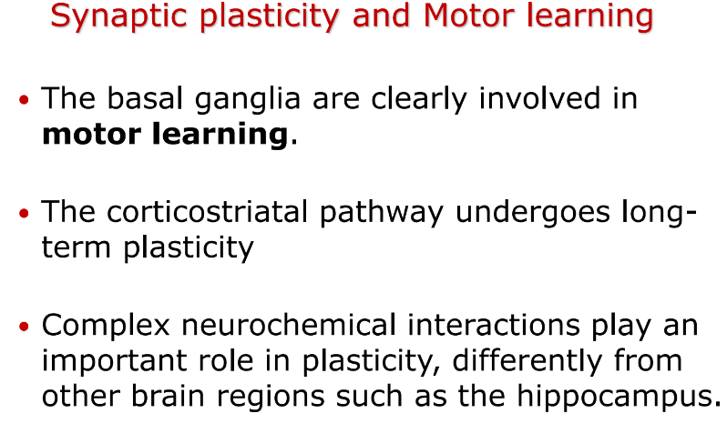

- basal ganglia is involved in motor learning

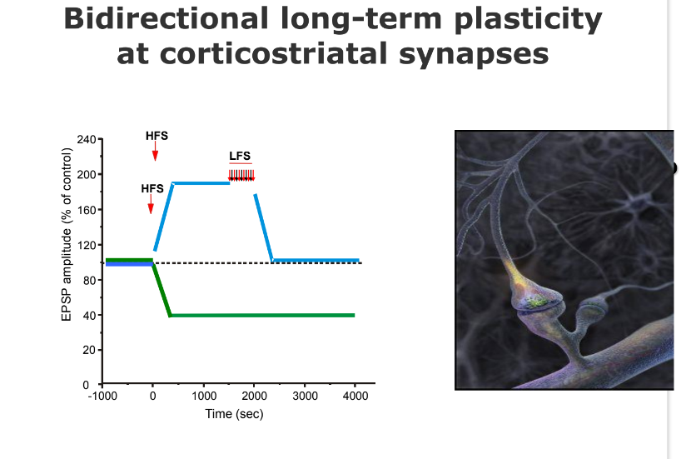
if we give high frequency to corticostriatal pathway.

if you are awake you have 100 hz of actbit

depotentiation is enactive process
--
hippocampus involved in memory

what happens to unnecessary memory (during sleep they are erased). You might have experienced to wake up to remember to forget to do something because the brain was removed unnecessary things unless you have some association and tagged those memories
and so there is an emotional loop association and so it is not removed and it is recalled when you are awake

only essential information needs to be stored

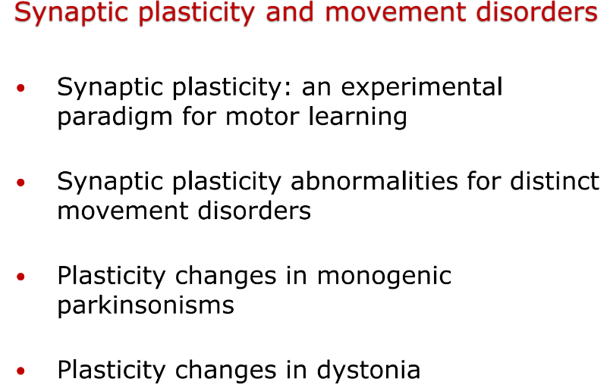

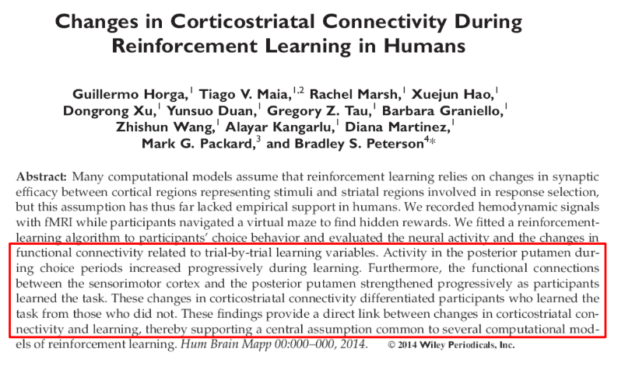
People were invited to do and learn a movement and progressively the connection improved. Signals were analyzed with MRI and were increasing because of connection between areas. These areas were reinforcing connection

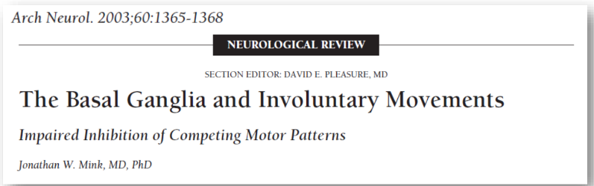
we have a combination and plenty of data regarding the role of basal ganglia in involuntary movements

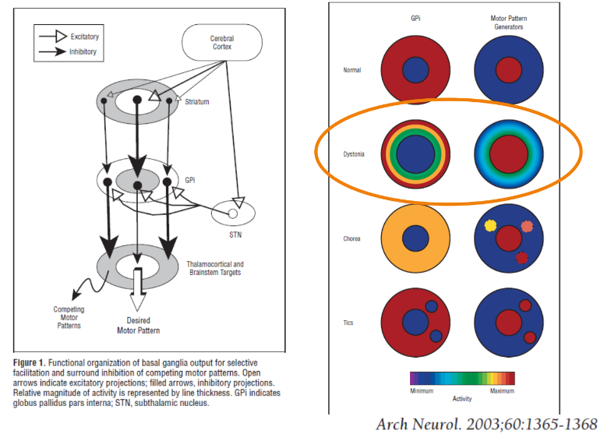

centre/s is excitatory and surrounds there must be inhibitory, otherwise the system will love the signal to noise ratio.

The centre surround is lost and we have dystonia (hyperkinetic disorder) there is an excess of movement that can be visualised by an increase in the centre. The centre will lose the ability to filter and the surround will still be active

in this disorder there are more than one centre there is a sort of random inhibition of movement that are voluntary movement that affect motor behaviour of patients

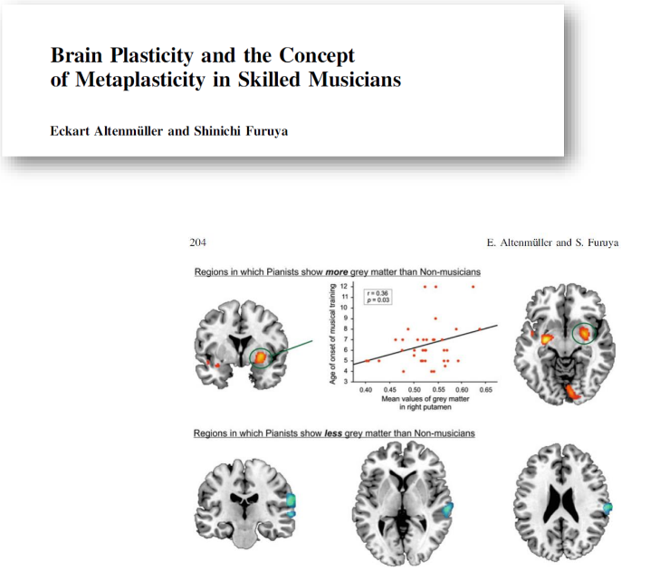
Plastic phenomena. (meta plasticity is plasticity of plasticity)
Playing an instrument requires sensory and motor information. Generation of action plans and selection and retrieval of highly refined movement patterns from procedural motor memory.

In some instances some movements are overlearned (because when children start to learn an instrument stay years performing always the same exercise, just to get familiar with that). And so musicians must undergo extensive training periods, the process of practice involves assembling, sorting and improving a combination of sensory and motor programs.

⟹ motor learning and plasticity. In this case we can call metaplasticity

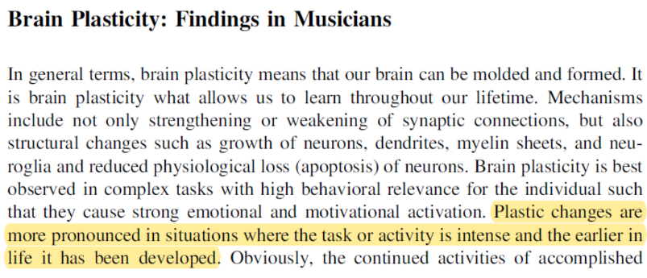
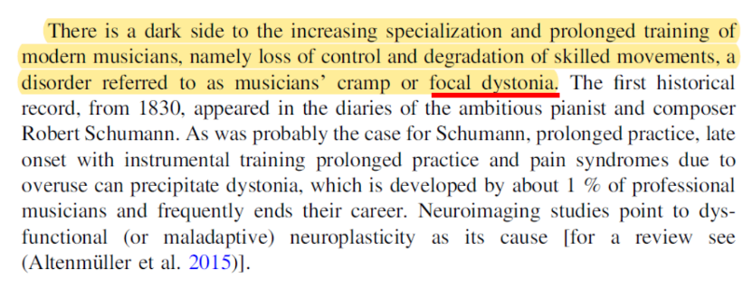
It might happen that such a plasticity mechanism might derange from physiological activity. In some cases you get "musical cramp" or focal dystonia. This happens frequently (1%, it is a lot)

While playing (piano, guitar, violin) those guys face the inability to carry on because of cramp (a movement that causes torsion) and they have to stop.
Commonly those guys will stop the career

If we understand how motor learning and plasticity works we understand how a disorder of movements can be manifested in these conditions.

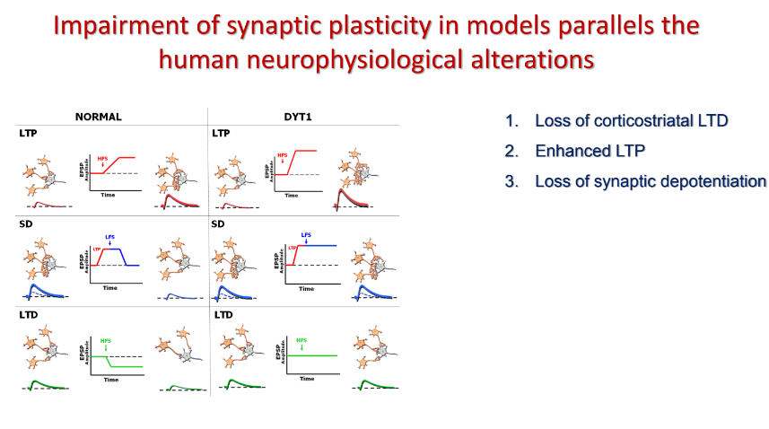
Probe synaptic plasticity in vitro. In the distonia model we see that LTP is increased and there is no way to induce synaptic depotentiation. We have a loss of inhibition
you can not take advantages anymore of the action selection, movements get together and make a mess. One tool is electromyography tools to record the activity of muscle.

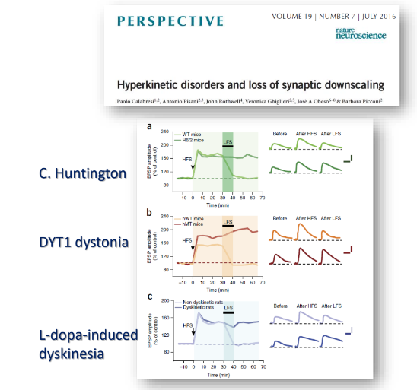
we have this alteration in a lot of movement disorder

MODEL OF MOVEMENT DISORDERS
*

LEZIONE 3
PARKINSON DISEASE

How movements are created and how the memory of movements are stored and retrieved.
We can have diseases (like parkinson)

Social impact which other diseases do not have

PARKISON DISEASES
Not only from social but also from economic point of view

in Italy 250000 people are affected (maybe more) but it will increase.
The main risk factor is age. Increasing age means that the brain gets old and some processes are going down ar not going the same way that goes when we are younger

PARKISON DISEASES. ECONOMIC BURDEN
in some countries like China and India are expected to significantly increase the number of people affected compared to European countries which are relatively stable. Two reasons why some countries are more effective than others are related to parkinson.
- ability to communicate diagnosis: is some countries is not given for granted, data from china and india are unreliable no one knows how many people died during covid
⟹ EU countries have a sort of registry that can be reliable
- countries that are becoming more western (in way of life and economics) will get the disease of western word (like multiple sclerosis)

Those diseases are expensive, you pay people for years. A stroke is less effective (you live or you die) while assistance, care, periodic evaluations are expensive

GRAPH
Tumours are the most expensive while parkinson is in the middle but only because we do not have novel drugs.
In multiple sclerosis we have novel drugs but they are very expensive. Treatments 30 thousands per year and per patient.

Meanwhile we manage to create new drugs and new strategies but the system is not increasing the ability.

Parkinson disease was described back in 1817 by a physician who defined the disease as shaking palsy. A paralysis but meanwhile shaking.

NEUROPATHOLOGY PARKINSON'S DISEASES
degeneration of +compl of region of brain pigmented with a black pigment that is completely gone from a patient.

From a clear pigmentation it is lost. This is because the main region of the brain is made of dopaminergic neurons, neurons that produce neurons. Without dopamine we have an unbalanced in the circuit defined before

INTRODUCTION
In terms of neuron pathology we have lewy bodies. This is made of a protein that precipitates in the cell. Basically it kills the cell.

1997 first description of the genetic component of parkinson disease. Family with genese producing +compl

ALPHA SYNUCLEIN
alpha synuclein found to be the main component of lewy bodies. We don't know yet how they works

REVIEW
one idea to pathological notion, because alpha synociel.
Since stnucle is localised in the terminal in the stnapici terminal synuclein works (it is required for normal functioning) but when it is muted we have a disruption of the function and the first damage is synaptic terminal and then it goes back to the cell
synaptic failure is a main event in parkinson disease

2008
People try to take substantia nigral and make transplants in the brain of patients. These embryonic graphs were taking and getting the same pathological features.
In principle if you are able to transplant something from a healthy condition (embrions) but put it in the wrong environment it was causing synuclein to get in the cell and kill them.

MOVEMENT DISORDER
the overall concept is that synuclein may just form a cell to the other and like an infection mechanism and infect other cells. Once the process begins it expand

BRAIN INTRODUCTION OF ALPHA SYNUCLEIN
exosomes and small particles isolated. I can search form exosomes (made of synuclein)

this means that is not into the cell just but it goes outside

2003 ELSEVIER
Concept of spreading of pathology and they analysed the brain of patients of parkinson and analyse how it was distributed depending on the severity of the deases

There is a start in the brain and goes up and potentially involves the cortex and the whole brain.

We know know there that there are pre motor
like olfactory loss because the function of the olfactory bulb that we have import slip programs and the centers that regulate sleep are down.

the substantia ngra

The Brak hypothesis that the diseases spread from down to the upper regions of the brain make sense.

Populations with sleep disorders were observed from 10 to 20 years and about 90% of people with sleep disorders converted to parkinson disease.

THe Brak hypothesis was mostly correct

SYNUCLEINOPATHIES TAUOPATHIES
based on the distribution of nucleic acids you can get Parkinson. And synuclrioèatheis give you multiple system atrophy.
It is always synuclein that +compl

NEUROBIOLOGY OF DISEASE POST MORTEM CEREBROSPINAL FLUID
People that are dead analyse the brain and measure the content.

ANTEMORTEM DETECTION OF PARKISON'S DISEASE
death according to biopsies, it is found in submandibular glands that can find synuclein. Try to make a validated diagnostic tool with artificial intelligence

The detection of synuclein is density and specific for advanced parkinson disease. Try a convolutional neural network for detection of synuclein of 283 digital whole slide images.

Make a sort of mask and the system gives you back the response with a match or not.

POTENTIAL DIAGNOSTIC SIGNIFICANCE
Find a match with high sensitivity and specificity. With ML it is possible to have consistent data to apply ML methods to teach the system to recognise and give you back meaningful feedback on the question you are posing.

